SDWG - Form Definition and Questionnaire Response Subgroup Meeting

Logistics:
Date / Time: March 19, 2013, 3:00pm to 4:00pm EDT
Location: Telco
Facilitator: Martin Rosner
Note taker: Martin Rosner

-------------------------------------------------------
Meeting information
-------------------------------------------------------
Topic: Questionnaire and Response HL7 IG Drafting
Date: Every Monday, from Monday, January 28, 2013 to no end date
Time: 3:00 pm, Eastern Standard Time (New York, GMT-05:00)
Meeting Number: 499 376 271
Meeting Password: (This meeting does not require a password.)

-------------------------------------------------------
To start or join the online meeting
-------------------------------------------------------
Go to https://continuaalliance.webex.com/continuaalliance/j.php?ED=18250233&UID=492541537&RT=MiMxMQ%3D%3D

-------------------------------------------------------
Audio conference information
-------------------------------------------------------
To receive a call back, provide your phone number when you join the meeting, or call the number below and enter the access code.
Call-in toll number (US/Canada): 1-650-479-3208
Global call-in numbers: https://continuaalliance.webex.com/continuaalliance/globalcallin.php?serviceType=MC&ED=18250233&tollFree=0

Access code:499 376 271
-------------------------------------------------------

Attendees:
Name | Affiliation | Present
Asim Muhammad | Philips | X
Brian Scheller | Healthwise | X
Chris Melo | Philips Healthcare
Emma Jones | Allscripts
Jessi Formoe | Intuit Inc.
Jim Kretz | SAMSA
John Feikema | ONC
Lisa Brooks Taylor | AHIMA
Lisa Nelson | Life Over Time Solutions
Martin Rosner | Philips | X
Rick Geimer | Lantana
Stephen Chu | National E-Health Transition Authority
Vin Sekar | National E-Health Transition Authority
Vinayak Kulkarni | Siemens | X

Agenda:
- Review of Form Definition Document draft IG
- Status on Questionnaire Response draft IG

Minutes Approval:
Mar.12.2013 (available on wiki) - approved

Action Items:
- Lisa – check on LOINC code assignments – Done – follow-up expected from Jamalynne Deckard – asking for review of drafts and should be no problem to issue LOINC codes – we should capture the places in the spec where we need those.

Review of Form Definition Document draft IG

We review comments from Brian. Reviewed document is here:

Brian also wonders if we can support something like this:

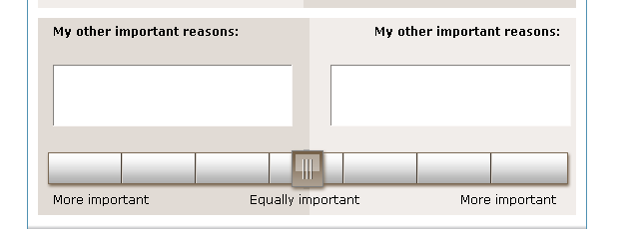

Should be possible.

Asim reviews latest draft:

Branching logic – currently supporting AND as a default. Ask at the next SDWG call.

Can we also enable ‘jump-to’ functionality – to be determined/asked if SDWG has any ideas.

Status of Questionnaire Response draft IG

We review comments from Lisa.

RecordTarget (universal header)
- patientRole – do we need addr and telecom? In general – do we have to be a child of Patient Generated Header? Are there any advantages. Ask SDWG.
- Same issues for the Patient.

AOB

Next Regular Call
- Mar. 26th, 2013, 3:00-4:00 ET

