Clinical Assessment Use Case – Assessing Head Injury Severity
The purpose of this use case is to describe the process for assessment of patient’s head injury severity of patient.
Note: Neurological assessment of patient with brain/head injury consists of extensive list of patho-physiological parameters
Glasgow Coma Scale, behavior/cognition, pupillary reaction, vital signs including spO2, vomiting, motor weakness) assessments and
Diagnostic tests (x-ray, CT, MRI).
To make this use case manageable, it limits the scope of assessment to illustrate the use of a specific assessment instrument (the Glasgow Coma Scale) as part of the clinical assessment process.
Use Case Sequence of Steps
- A 26 yo male patient is brought into ER by ambulance after being involved in a motor vehicle accident.
- Initial assessment reveals that the patient has a deep laceration of the scalp (left temporo-occipital), decreased level of consciousness, disoriented to time and place, and quite restless. An ER nurse is assigned to look after this patient.
- After an initial examination and assessment of the patient, the ER physician makes the provisional diagnoses of laceration of head and traumatic brain injury (TBI). The physician initiates the hospital closed head injury management protocol which includes hourly head trauma neurological assessment.
- The ER nurse assigned to look after this patient starts a head injury observation chart which includes a GCS component. At each hour, and using the GCS chart, the nurse observes and records result of the observations on the following parameters:
  - Eye Open:
Spontaneous (4)
To speech (3)
To Pain (2)
None (1)
  - Verbal Response:
Oriented (5)
Confused (4)
Inappropriate words (3)
Incomprehensible sounds (2)
None (1)
  - Best Motor Response:
Obeys command (6)
Localizes to pain (5)
Withdraws (4)
Flexion to pain (3)
Extension to pain (2)
None (1)
Recording the GCS observation findings:
- Component Scores:
The observation value of each GCS component can be graphed to show the trend:

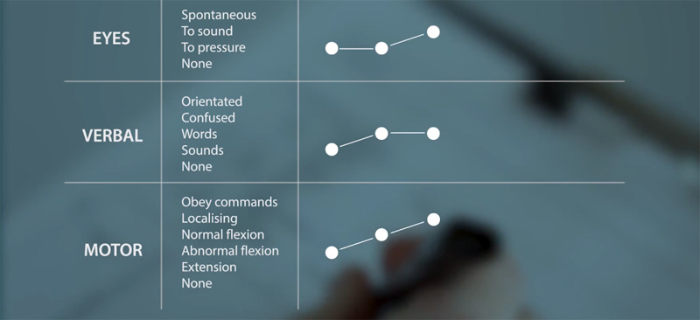

- Total score:
The total score is a sum of each component score. It provides overview summary of the severity of the patient's head injury.
Example: GCS = 11
However, it is important to note that this total score does not communicate the more informative detailed description of each response, for example, that a total score of 8 could be E2V2M4 or E1V1M6, with very different implications for the severity of the patient's condition
Therefore, in addition to the total score in clinical care for each observation, the short hand component score should always been included:
E3V3M5 = GCS 11

The Clinical Assessment:

The clinical assessment of patient with head injury includes the analysis of the neurological observation data (including identifying the trends discerned from comparing the collection of observation data over a time series) to arrive at a clinical judgment of the patient’s head injury severity and changes in severity.

The shorthand component score and total score are used to support determining the head injury severity, for example:
- A score of 13-15, 9-12, 5-8 and 3-4 indicates minor, moderate, severe and very severe injury

Point in time changes in the total score or individual score(s) may trigger clinical review or rapid medical responses:
- Clinical review criteria:
- A drop in 1 point on the GCS or the patient is no longer responding to command
- New onset of limb weakness
- New cranial nerve deficit
- Persistent severe headache, vomiting, and/or agitation
- Rapid Medical Response Criteria
- A drop in 2 or more points on the GCS
- GCS ≤8
- Changes in pupil size in association with pupil dilation and/or loss of light reaction
- Seizure activity

The outcomes of head injury clinical assessment include:
- Establishing the initial diagnosis and severity
- Updating diagnosis and severity level
- Initiating and updating head injury management plan

KO D. Y. Clinical evaluation of patients with head trauma, Neuroimag. Clin. N. Am., 2002, 12 : 165-174
Adult Neurological Observation Chart, Australia NSW Agency for Clinical Innovation, 2013

