Orders & Observations Conference Call

15 February 2017

+1 770 657 9270, Passcode: 398652#

WebURL: https://join.me/vernetzt.us

Attendees:

 | Name | Organization
1 | Riki Merrick | Vernetzt, LLC / APHL
2 | Kathy Walsh | LabCorp
3 | Andrea Pitkus | IMO
4 | MariBeth Gagnon | CDC
5 | Rob Hausam | Hausam Consulting
6
7
8
9
10
11
12
Regrets:

Co-Chair: Riki Merrick
Scribe: Riki Merrick

Agenda/Minutes:
- Agenda Review
- Approve minutes – defer until we have completed the spreadsheet
  - from May 6, 2016: : http://wiki.hl7.org/index.php?title=File:SPM_Minutes_20160506_ConCall.docx
  - from May 27, 2016:http://wiki.hl7.org/index.php?title=File:SPM_Minutes_20160527_ConCall.docx
  - from June 3, 2016: http://wiki.hl7.org/index.php?title=File:SPM_Minutes_20160603_ConCall.docx
  - from June 10, 2016: http://wiki.hl7.org/index.php?title=File:SPM_Minutes_20160610_ConCall.docx
  - from June 17, 2016: http://wiki.hl7.org/index.php?title=File:SPM_Minutes_20160617_ConCall.docx
  - from June 24, 2016: http://wiki.hl7.org/index.php?title=File:SPM_Minutes_20160624_ConCall.docx
  - NO CALL ON July 1, 2016
  - From July 8, 2016: http://wiki.hl7.org/index.php?title=File:SPM_Minutes_20160708_ConCall.docx
  - From July 15, 2016: http://wiki.hl7.org/index.php?title=File:SPM_Minutes_20160715_ConCall.docx
  - From July 22, 2016: http://wiki.hl7.org/index.php?title=File:SPM_Minutes_20160722_ConCall.docx
  - From July 29, 2016: http://wiki.hl7.org/index.php?title=File:SPM_Minutes_20160729_ConCall.docx
  - From August 5, 2016: http://wiki.hl7.org/index.php?title=File:SPM_Minutes_20160805_ConCall.docx
  - From August 12, 2016 – NO Quorum
  - From August 19, 2016 – http://wiki.hl7.org/index.php?title=File:SPM_Minutes_20160819_ConCall.doc
  - From August 26, 2016 - http://wiki.hl7.org/index.php?title=File:SPM_Minutes_20160826_ConCall.doc
  - From September 2, 2016 – NO Quorum
  - From September 9, 2016 – No call
  - From September 16, 2016 - http://wiki.hl7.org/index.php?title=File:SPM_Minutes_20160916_ConCall.docx
  - From October 14, 2016 – NO Quorum
  - From October 28, 2016 – NO Quorum
  - From November 2, 2016 - http://wiki.hl7.org/index.php?title=File:SPM_Minutes_20161102_ConCall.docx
  - From November 9, 2016 - NO Quorum
  - From November 16, 2016 - NO Quorum
  - From December 14, 2016 - http://wiki.hl7.org/index.php?title=File:SPM_Minutes_20161214_ConCall.docx
  - From December 21, 2016 - http://wiki.hl7.org/index.php?title=File:SPM_Minutes_20161221_ConCall.docx
  - From January 4, 2017 – NO quorum
  - From January 11, 2017 - http://wiki.hl7.org/index.php?title=File:SPM_Minutes_20170111_ConCall.docx
  - From January 25, 2017 - http://wiki.hl7.org/index.php?title=File:SPM_Minutes_20170125_ConCall.docx
  - From February 1, 2017 - http://wiki.hl7.org/index.php?title=File:SPM_Minutes_20170201_ConCall.docx

- Compare Specimen DAM to biologic specimen model in BRIDG - map specification source is BRIDG and the map to is specimen DAM
Spreadsheet = http://www.hl7.org/documentcenter/public/wg/orders/Copy%20of%20Copy%20of%20BRIDG%20to%20Specimen%20DAM%20Mapping%20Spreadsheet%20as%20of%2020170215.xlsx

EA file is here:
http://www.hl7.org/documentcenter/public/wg/orders/V3_DAM_Specimen_R1_2014May-BRIDG_Discussions.zip
The spreadsheet:

Ballot document:
http://www.hl7.org/documentcenter/public/wg/orders/V3_DAM_Specimen_R2_INFORM_2017JAN_20161102.docx

Also Raj sent this file:
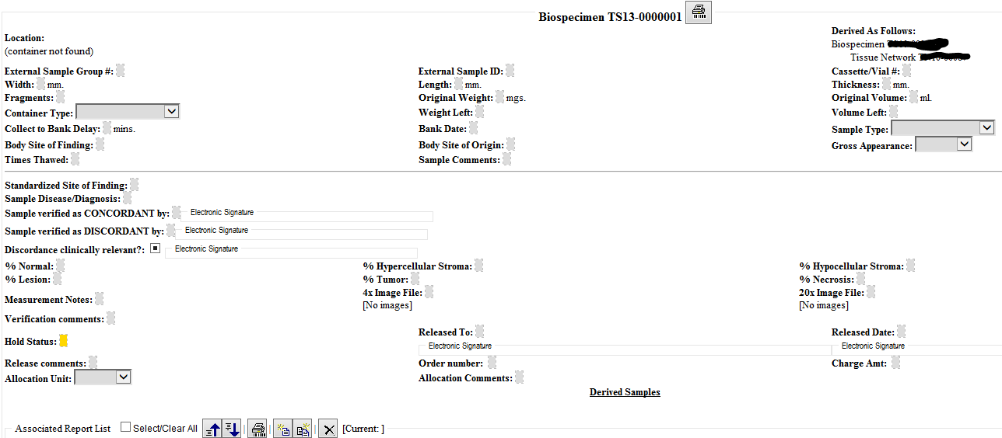

We have these items left in these classes:
We filtered on Draft and Source-change and wet through these rows:
Rows 171 and 172 = check with Wendy what the association here means and how that should be mapped – for associatedOrganziation we have name and identifier attributes – possibly related to Rows 608 and 609?
Row 348 = SpecimenMoveActivity approved and created definition
Row 349 = we are not maintaining this kind of hierarchy in the DAM, so marked as implementation specific and approved
Rows 608 and 609 = Performer.associatedOrganizationIdentifier and Performer.associatedOrganizationName were added – now need to apply to the mapping for Performer associated with SpecimenCollectionProcedure – Riki to ask Wendy how to best do that and if that might be captured in Rows171 and 172 the performing and collecting laboratory elements
Row 623 = Subject.identifier(identifier)value = added the definition and approved – need to check that we really only want 1 ID and ID is optional?
Row 624 = StorageEquipment.storageEquipmentIdentifier(identifier).value = added definition and approved
Row 628 = StorageEquipmentComponent.storageEquipmentComponentIdentifier(identifier).value = added definition but want to check with Wendy about the definition for StorageEquipmentComponent and how to best add that into this spreadsheet, since that is new material for BRIDG as well
Row 630 = Subject.identifier(identifier).assigningAuthority = added definition and cardinality = 1..1 and approved
Row 974 = approve mapping for SpecimenCollectionProcedure
Rows 1194 and 1195 = Reconsidering if we want to add MaterialExpirationDate and MaterialLotNumberText – since that is ONLY on subject in the DAM, does not seem to make sense –> FOLLOW UP RESEARCH:
Per minutes 8/05/16 we decided to add both:
Product – used in any procedure or process – implementation specific DAM does not use parent classes; how do you differentiate between specimen vs product – product is subclass of material (which can play the role of specimen); may need to track brand names of specimen to be tested – like eyedrops, or crackers
Product.classCode – supported – maps to Material.materialClassCode
Product.codeModifiedText – out of scope (use case is autoencoder, in order for that to work must change the text)
Product.expirationDate – will add to material in DAM as optional element
Product.lotNumberText – will add to material in DAM as optional element
Product.per1938Indicator – out of scope
Product.typeCode – compare to material.code in BRIDG – what we have in DAM as material.typeCode is defining what it is, whereas the material.typeCode in BRIDG is more of a higher level category of grouping types together – mark as out of scope
Product relationship to material – implementation specific

We will have a call next week!
Call adjourned 5:07 PM ET, so not further discussed:

Subject.performingSpecimen – how should we represent when tissue from a tissue bank is a specimen – we think it would still fall under person, only de-identified, because currently our material is ONLY from non-living subject

Subject.performingSpecimen: find out if we need this

Specimen.containingSpecimenCollectionGroup – and related attributes

- SpecimenMoveActivity – on hold until we Review the IHE Specimen Event Tracking (SET) profile for data elements that are required there – keeping these notes for when we get back to this topic
  - when nothing changes in the specimen – there are other processing activities that don’t result in new specimen, so need to verify in the EA model that the association between specimen and specimenProcessingActivity labeled “results in” has a cardinality of 0..*
  - since we are only concerned with the actual instance tracking, not the protocol creation should we rename this class to PerformedSpecimenMoveActivity – yes
  - cardinality should be 0..*
  - Approve this class
  - What attributes do we need: currenty BRIDGE has 3 to represent the different coordinates possible – we have a datatype that does this so have fromCoordinates and toCoordinates – hence one of our attributes maps to 3 BRIDG attributes
  - What about building location – we have geographicalLocation as a data type – currently an attribute of storageEquipment
  - Would a holder also need a geographicalLocation?
  - Would it be better to create a fromLocation and a toLocation attribute, that can use either the coordinates or the geographicalLocation dataytpes?
  - We already discussed adding SpecimenMoveActivity.TakenFromElementIdentifier, which is similar to have a fromEntity and a toEntity that can be referenced and you could reference the holder and the storageEquipment, which in turn have coordinates and geographicalLocation attributes?

- Resources:
  - Link to BRIDG model: http://bridgmodel.nci.nih.gov/files/BRIDG_Model_4.0_html/index.htm - chose VIEW:BSP - biospecimen
  - Link to Specimen DAM: http://wiki.hl7.org/index.php?title=Specimen – scroll to bottom for image

